Xplore Group

Business Opportunity and Feasibility Analysis

Appendix

Providing a Truly Memorable Experience

Professor Jackie Kimzey
Group5

Miguel Franco
Steven Hernandez
Kevin Patel
Yuchen Sun

Appendix I: Double-Decker Bus Suppliers Considered
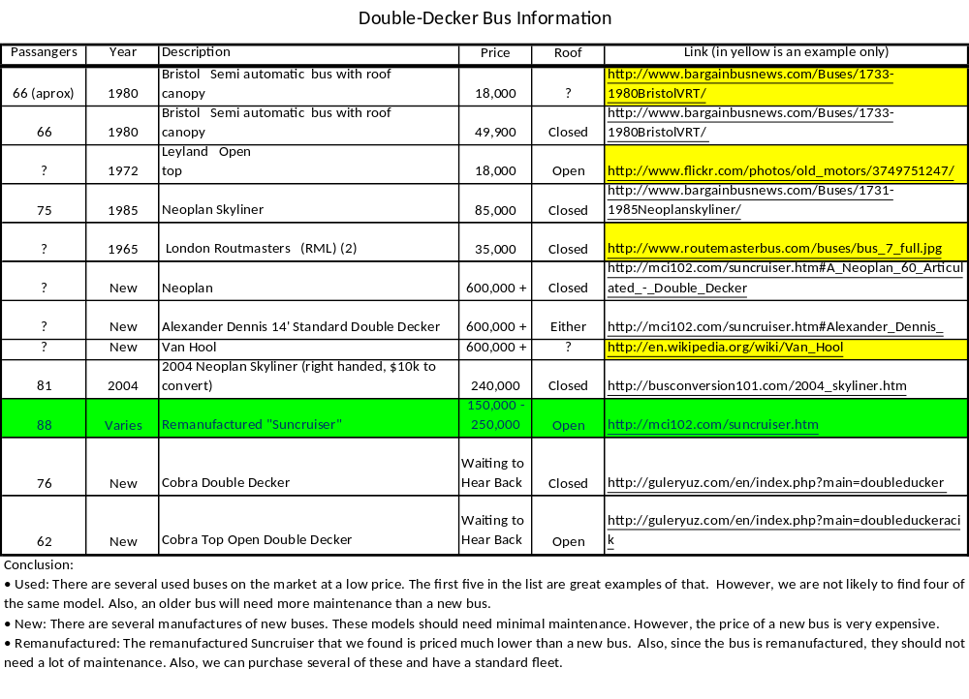

Appendix II: Average Weather in Panama City

Month | Mean Temperature of |  | Mean Total Rainfall (mm) | Mean Number of Rain Days
Month | Daily | Daily | Mean Total Rainfall (mm) | Mean Number of Rain Days
Month | Minimum | Maximum | Mean Total Rainfall (mm) | Mean Number of Rain Days
Jan | 65.3 | 92.1 | 29.3 | 2.9
Feb | 65.1 | 93.6 | 10.1 | 1.3
Mar | 65.1 | 94.6 | 13.1 | 1.4
Apr | 67.1 | 95.7 | 64.7 | 4.9
May | 70 | 94.1 | 225.1 | 15
Jun | 70.3 | 92.8 | 235 | 16
Jul | 69.8 | 93 | 168.5 | 14
Aug | 69.6 | 93 | 219.9 | 15
Sep | 69.8 | 91.2 | 253.9 | 17
Oct | 69.4 | 90.7 | 330.7 | 20
Nov | 68.5 | 91.2 | 252.3 | 16
Dec | 66.6 | 91.9 | 104.6 | 7.5
10.91667 | Average of the Average Number of Rainy Days
1.07967 | Number of Buses with Closed Tops (As a percentage of Expected Rain and Assuming 3 Buses)

Reference:
http://www.worldweather.org/076/c01221f.htm#climate

Appendix III: Suncruiser Bus Layout

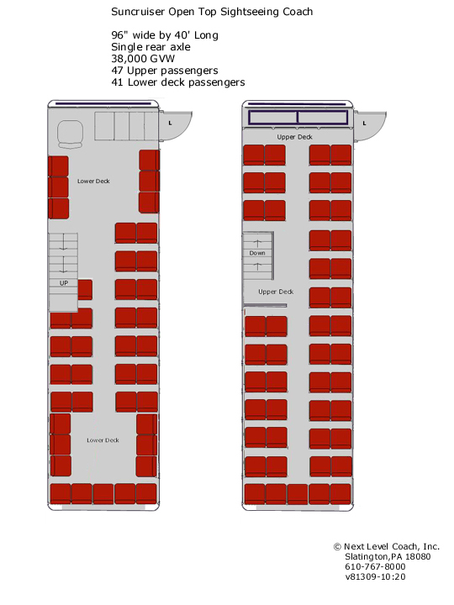
Reference:
http://mci102.com/images/Suncruiser%20Open%20Top-40%20ft.jpg

Appendix IV: Bus Stops

Stop 1 Naos Island
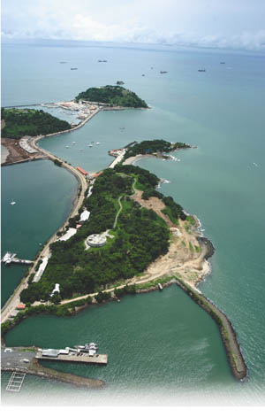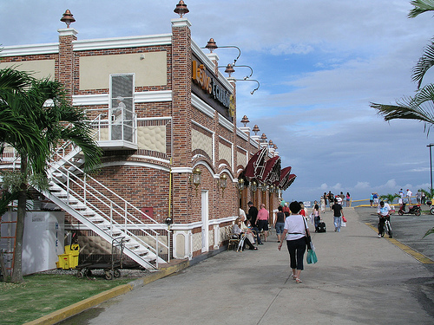

Stop 2 Biodiversity Museum
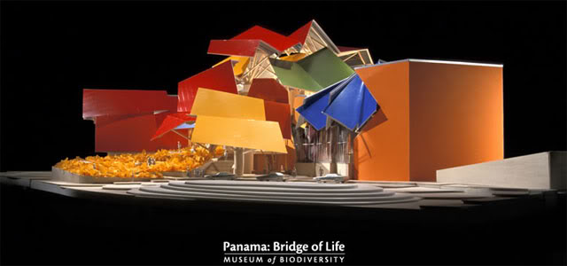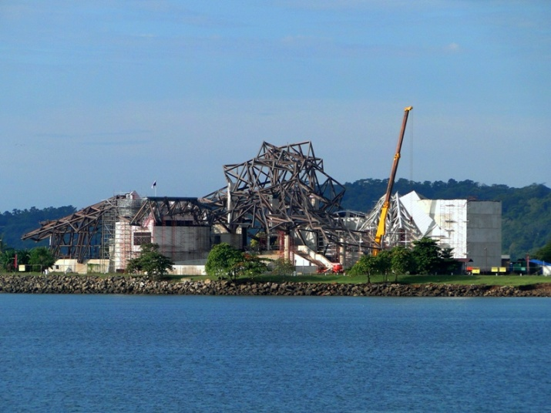

Stop 3 Casco Viejo – Plaza Francia
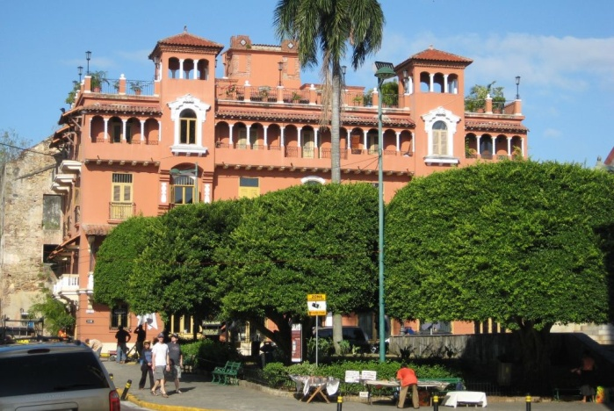

Stop 4 Casco Viejo – Plaza Catedral
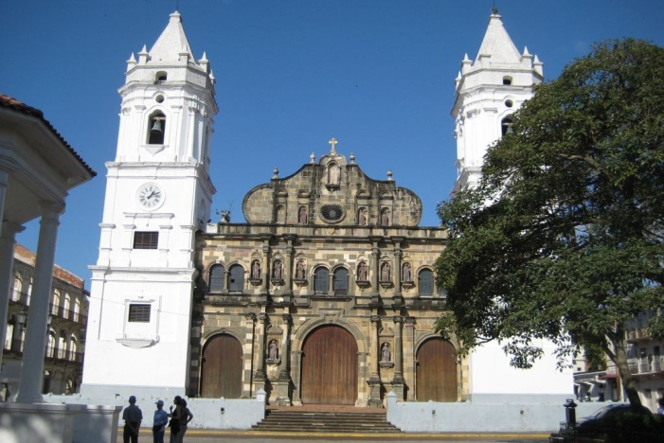

Stop 5 Cinta Costera
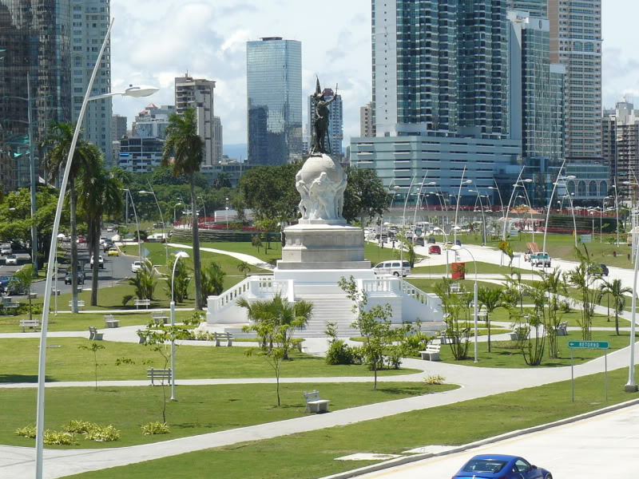

Stop 6 Multicentro
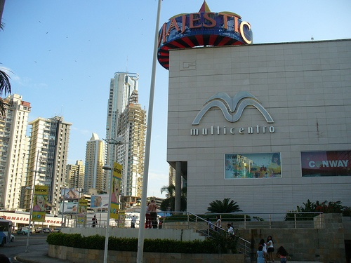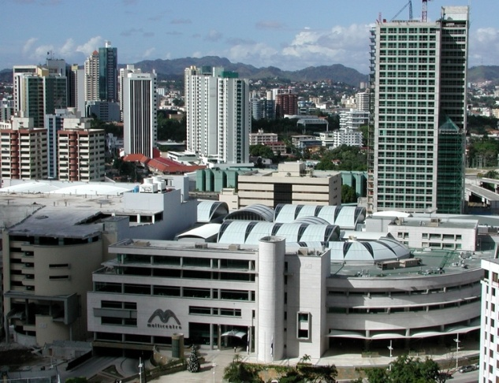

Stop 7 Multiplaza
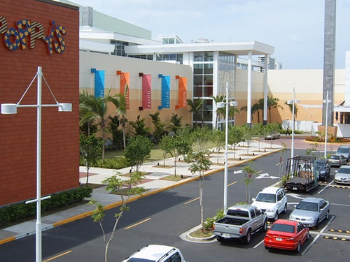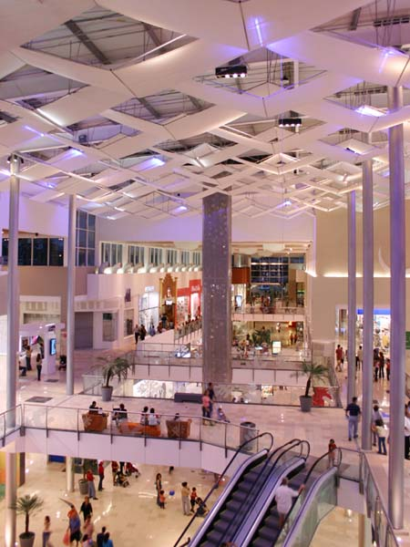

Stop 8 Atlapa
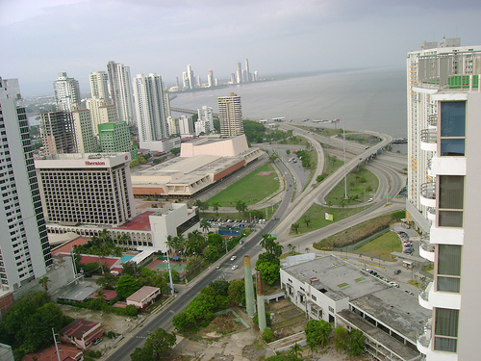

Stop 9 Panama Viejo – “Old Panama”
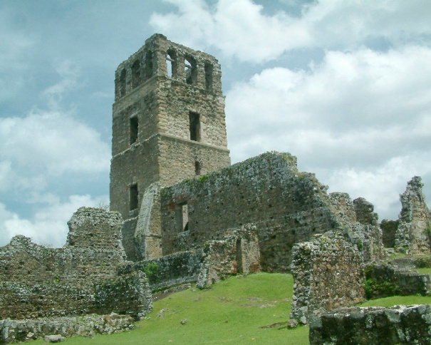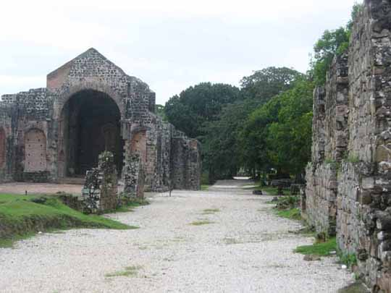

Appendix V: Bus Route

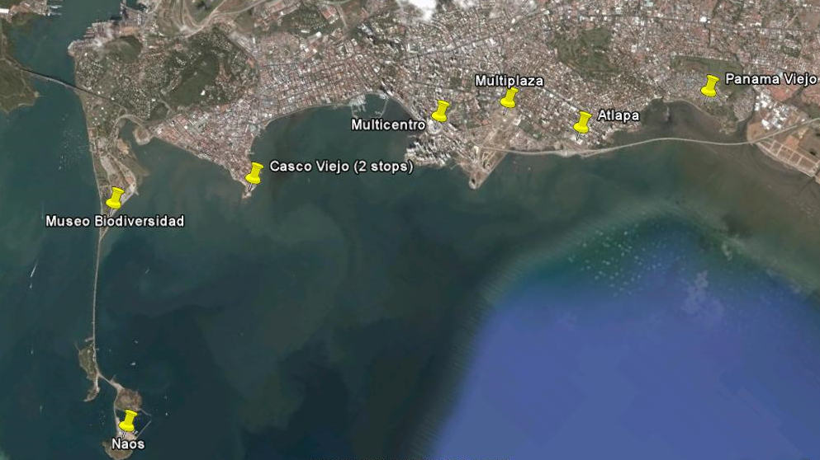

Appendix VI: Potential Customer Survey and Analysis

I. Survey questions
Altogether eight questions were included in the survey to collect information about the tourist average time spent in Panama City, acceptable price range for the bus service, and factors that may influence customer satisfaction through the tour.
The detailed multiple choice questions are listed below.
- What’s your reason of coming to visit Panama City?
  - Touring Panama City and nearby areas
  - Participating in business meeting
  - Visiting family members/friends
  - My cruise travel starts/finishes/stops by Panama City
  - Other reason, please specify.
- How long will you spend in touring Panama City?
  - One day
  - Two days
  - Three days
  - If more than three days, please specify.
- When you plan the tour in Panama City, where will you get the information you need for the tour?
  - I will ask travel agent about the city and reserve tour guide service fits my needs.
  - I will ask hotel concierge about where to go in the city and tour the city by myself.
  - I will ask a local friend to guide the tour.
  - I will check Internet and travel guidebooks such as Lonely Planet for information I need.
  - I will ask local people I met when I wonder in the city.
  - Others please specify.
- When you are in Panama City, what kind of vehicle will you like to take to visit the city?
  - Take taxi
  - Rent a car
  - Buy tour guide service that include transportation
  - Take public bus
  - Reserve a limo
  - Others please specify.
- In touring the city, how much will you pay for a two-hour tour guide service in your native language covering introductions to major attractions of the city (excl. admission tickets)?
  - Less than $10
  - $10-$20
  - $20-30
  - $30-$40
  - $40-$50
  - Over $50
Appendix VI (Continued)

- Please tell us what makes your touring experience most enjoyable?
  - Seeing the great scenery of a city
  - Meeting friendly and interesting local people
  - Participating in local traditional activities
  - Enjoying local cuisine
  - Buying local souvenirs
  - Others
- Tell us about yourself. Your age is between:
  - 18~25
  - 25~35
  - 35~55
  - 55~
- When you travel, you are traveling
  - By yourself
  - With friend
  - With loved one
  - With family including kids
  - With family without kids

II. Survey Sampling
The survey was conducted mostly on line by using www.surveymonkey.com tools. The online survey questions were sent to selected UTD students who have shown interest in visiting Panama City in the future. Also, the survey link was posted on the Panama City section of travel discussion boards such as www.tripadvisor.com and www.cruisecritic.com.

III. Survey Result Analysis
For each of the questions, the breakdown of different choices is listed as follows.
- What’s your reason of coming to visit Panama City?
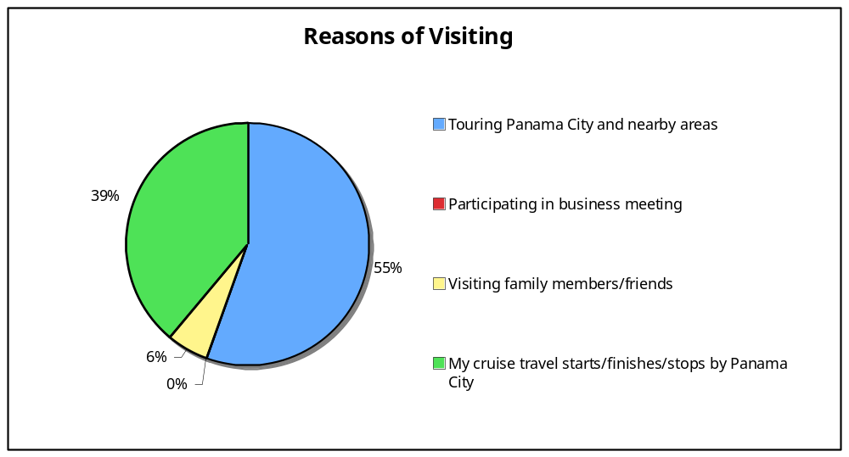
Appendix VI (Continued)

- How long will you spend in touring Panama City?
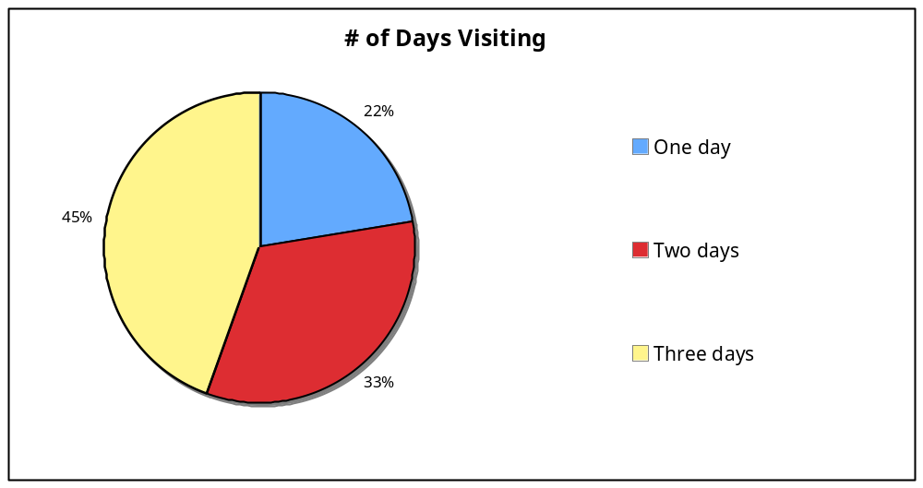

- When you plan the tour in Panama City, where will you get the information you need for the tour?
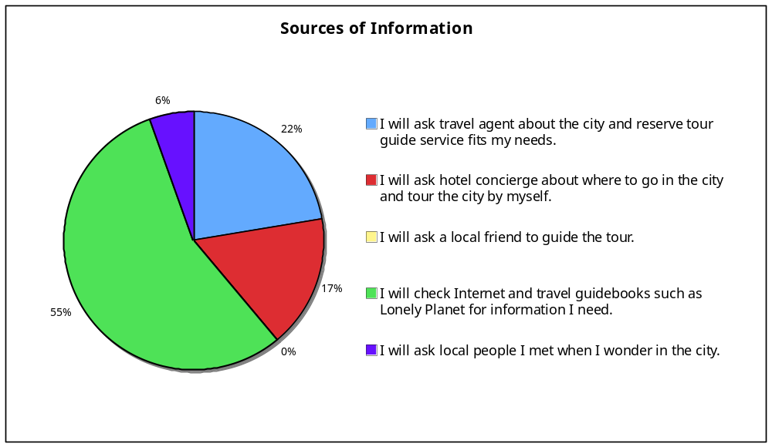

Appendix VI (Continued)

- When you are in Panama City, what kind of vehicle will you like to take to visit the city?
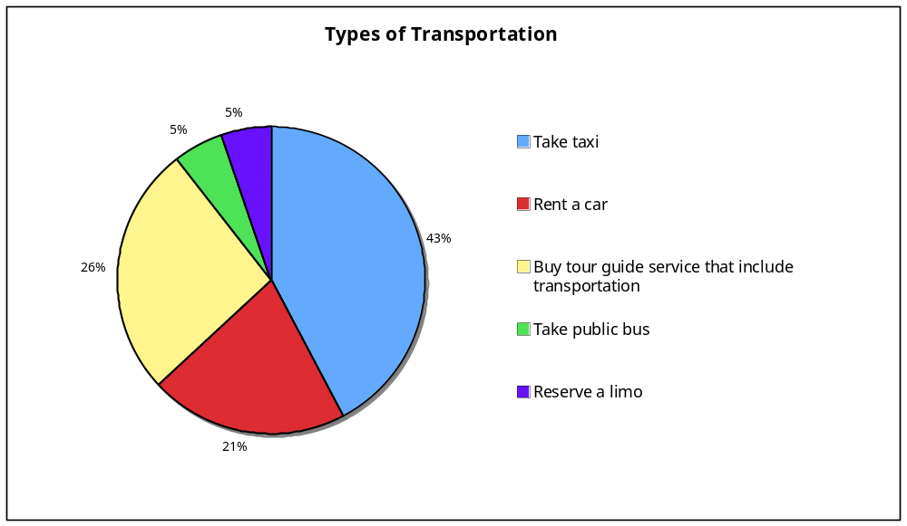

- In touring the city, how much will you pay for a two-hour tour guide service in your native language covering introductions to major attractions of the city (excl. admission tickets)?
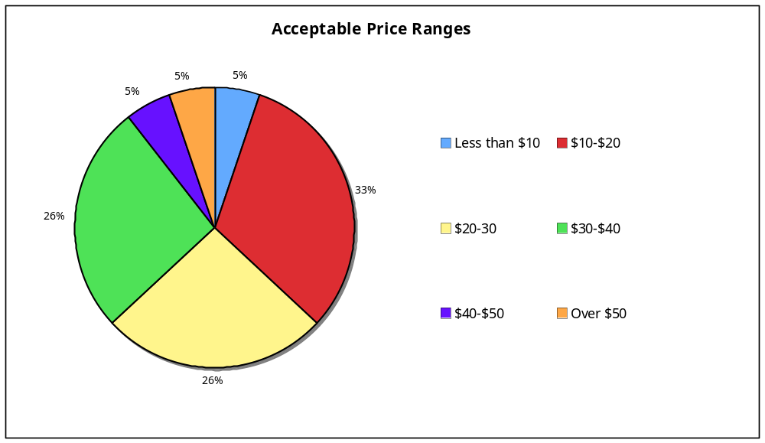

Appendix VI (Continued)

- Please tell us what makes your touring experience most enjoyable?
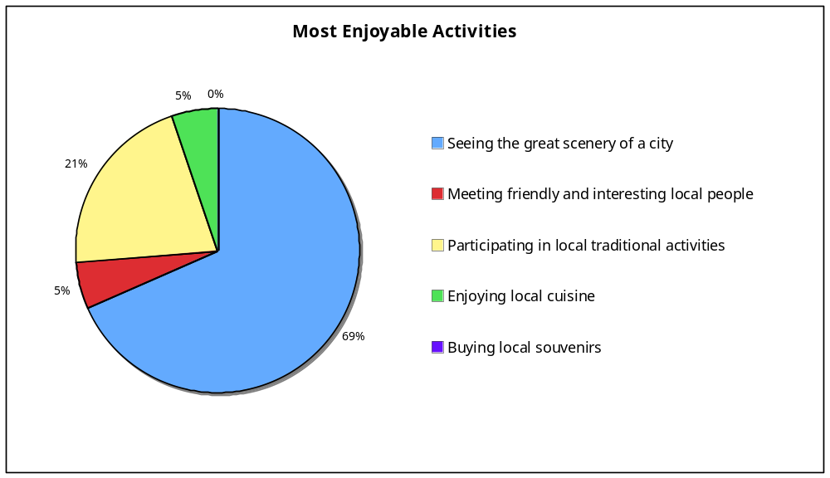

- When you travel, you are traveling …
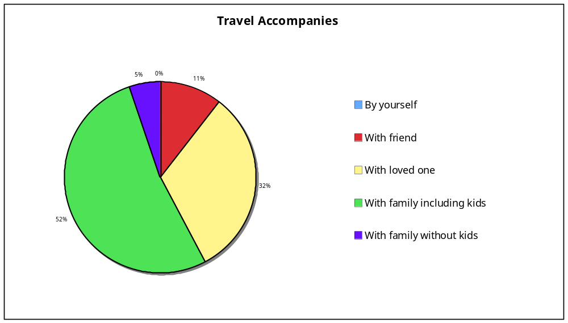

Appendix VI (Continued)

- Tell us about yourself. Your age is between:
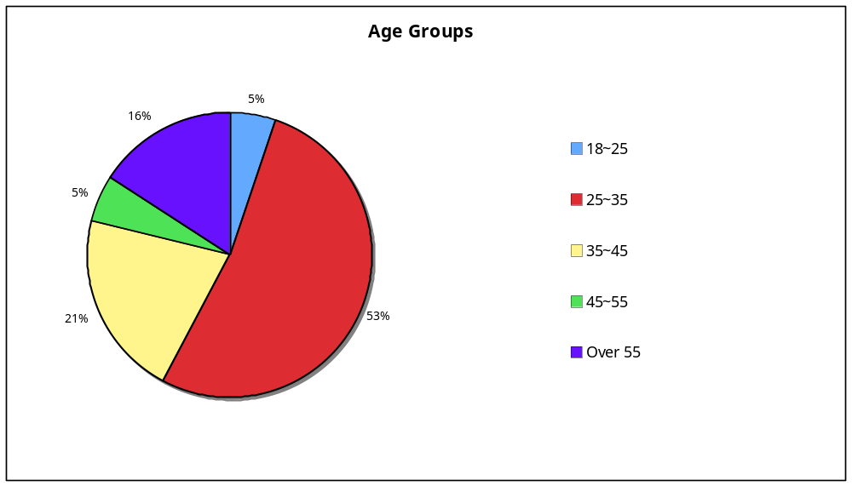

Appendix VII: Visitor Segmentation

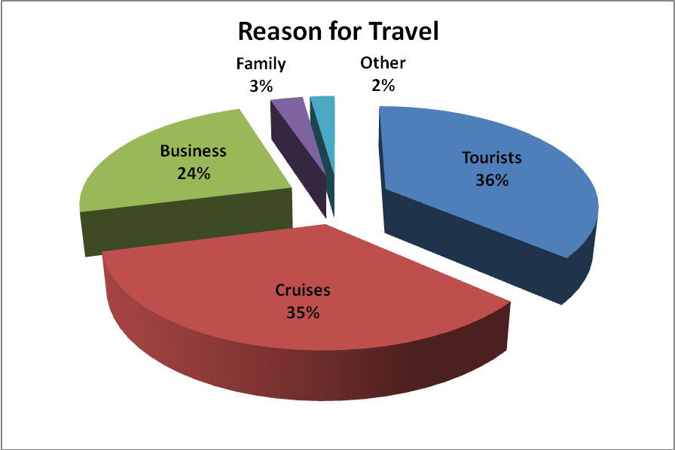

Reference:
http://www.atp.gob.pa/archivos/pdf/demanda_oferta.pdf

Appendix VIII: Competitor Comparison

Competitors | Service Advantages | Service Disadvantages | Price
Rental Car | Flexible | Difficult to find directions (streets not numbered), especially for non-Spanish speakers. | $160~200/week  Full size, auto transmission, without gas
Public Bus | Cheap | Safety is an issue;  Finding routes to destination will be difficult for international tourist, especially for non-Spanish speakers. | $0.5/ride
Tour Guides | Arranged trip | Schedule not flexible, may add mandatory visit to shops, | $75~100/day trip
Regular taxi | Cheap | Difficult to find taxi during peak hours; taxi refuses service in high traffic areas; attempts to increase rate to tourists; Most drivers speak no English | $3/15 min drive
Tour Taxi | Luxury cars, English speaking drivers | Expensive, need to reserve beforehand | $20~40/ride to one destination
Xplore open top double-decker bus | Flexible schedule (hop on, hop off); unique experience (open top); pre-recorded tour guide info. | Pre-selected routes, may not be available in all locations | $25/day pass

Appendix IX: Expert Feedback

- Carlos Cenjor of Hotelbeds: Company brings 22,000 visitors to Panama annually. He is very interested in Xplore Panama’s service and believes most customers would be interested. His company would be willing to add the tour service to their package, but he must be provided a discount. He was happy with a $5 discount per person on ticket prices. He also needs to see proof of insurance from the company.

- Javier Polanco of Expedia: About 50,000 people booked flights and/or hotel accommodations to Panama City through their website. Javier believes at least 20% of these customers would also purchase double-decker tour bus tickets through Expedia.

- Melissa Hegi of Hoteldo: Company brings 6,500 visitors to Panama annually. Although they have never sold “tourist packages,” they want to start doing it in May and would like to partner with Xplore Panama. Melissa believes most visitors would be interested in the double-decker bus tour. She would like to charge $8 to sell Xplore Panama’s services.

- Alejandra Marino of Tourico Holidays: Stated that Panama is one of the main destinations that they sell and promote, but could not give the number of visitors they bring. They normally charge $8 to sell tours in general, but given that Xplore Panama’s tour is significantly less expensive, they could come down on that price.

- Tour Audio System, Commentary Translation Service, and Audio Recording
Jason Pattison
www.sirian.com
www.coachsound.com
P: +61 7 3423 2543
F: +61 7 3423 2544
M: +61 (0)415 716 665
E: jason@sirian.com

- Service to Export Buses from Houston, TX to Port of Cristobal, Panama
Lorian Torres
Manager
CombiTrans, Inc.
Miami, FL 33172
P: (305)885-8478
F: (305) 885-8477
M: (305) 746-2537
Website: www.combitrans.com
Email: ltorres@combitrans.com

Appendix IX (Continued)

- Double-Decker Tour Bus
Sam Walker
Plant GM – Chief Designer
Next Level Coach, Inc.
P: 610-767-8000
E: steve@walkercoach.com
Suncruiser: www.OpenTopCruiser.com

Appendix X: Detailed Sales Forecast

2011 sales forecast | January | February | March | April | May | June
% of all visitors | 0.5% | 0.8% | 1.0% | 1.3% | 1.5% | 1.8%
Tickets sold | 1,053 | 1,593 | 2,087 | 2,150 | 2,369 | 2,751
 | July | August | September | October | November | December | Total
 | 2.0% | 2.3% | 2.5% | 2.8% | 3.0% | 3.3% | 1.9%
 | 3,488 | 3,858 | 3,672 | 4,909 | 6,308 | 7,457 | 41,696

2012 sales forecast | Quarter 1 | Quarter 2 | Quarter 3 | Quarter 4 | Year Total
% of all visitors | 3.0% | 3.0% | 3.0% | 3.0% | 3.0%
Tickets sold | 21,454 | 16,543 | 16,734 | 20,995 | 75,727

2013 sales forecast | Quarter 1 | Quarter 2 | Quarter 3 | Quarter 4 | Year Total
% of all visitors | 3.5% | 3.5% | 3.5% | 3.5% | 3.5%
Tickets sold | 28,334 | 21,848 | 22,100 | 27,727 | 100,009

Appendix XI: List of Potential Partners in Tourism Industry
(Emails & Phone #s have been removed)

Foreign companies that bring the most tourists to Panama:
Company | Contact | Address | Web
Gulliver Travel | Renata Cenni | Gullivers hours, 27 goswell road, london | www.gta-hotels.com
Hoteldo | Melissa Hegi | Sarmiento 1113 6º B | www.hoteldo.com  clickhoteles.com
Hotelbeds | Carlos Cenjor | Avda. Tulúm 318, Sm 09, Mza. 02 L.2, 1er piso Suites 107-114 77500 Cancún, Quintana Roo - Mex. | www.hotelbeds.com
Transhotel | Juan Mendizábal | C/ isla del hierro nº 3  28703 san sebastian de los reyes | www.transhotel.com
Tourico Holidays | Alejandra Marino | Buenos Aires, Argentina | www.touricoholidays.com

Online sites that bring the most tourists to Panama:
Company | Contact | Web
Expedia | Javier Polanco | www.expedia.com, www.hotels.com, www.venere.com
Orbitz | Ana Sagrian | www.orbitz.com, www.cheaptickets.com
Travelocity | Kathie Widowson | www.tracelocity.com, www.americanexpresstravel.com
Despegar | Paola Dimare | www.despegar.com
Destinia |  | www.destinia.com
Priceline | James Viera | www.priceline.com
Horse21 | Denis Demskiy | www.horse21.net
Hotusa | Lorena Montenegro | www.hotusa.com
Hotel.de/  hotel.info | Carlos Bohacek | www.hotel.de, www.hotel.info

Local Companies that bring the most tourists to Panama:
COMPANY | CONTACT | ADDRESS
Agencia de Viajes Fidanque | Emma Fidanque | El Dorado al lado de lumicentro.
Allegro Tours | Guadalupe Arguelles | Calle Manuel Marcia lcaza Área Bancaria a lado del Banco biasa diagonal al Ban café
Ancon Expeditions | Rick Morales | Bella Vista, Calle Elvira Mendez frente al edificio Vallarino
Aventuras 2000 | Dagmar Novey | Avenida Balboa frente a Multicentro
Pesantez Tours | Enrique ó Analida Pesantez | Paitilla, Centro Comercial Plaza Balboa
Gray Line / Viajes Primera Clase | Widnancy Aranda | Parque Lefevre calle 3ra.
Panamá Star Tours | Rina, Barbara | Via España a lado Banco Delta 1er piso
Turista Internacional | Angel Paredes | Via España y 12 de Octubre
Viajes Arco Iris | Alex Zapata | Ave. Justo Arosemena y Cl 45
Explora La Alianza / Viajes Ivonne, S.A. | Cristy Carrasco | Calle 50 Esquina con vía Brazil a lado de Wao

Appendix XI (Continued)

Companies that bring the most Brazilians to Panama:
NAME | ADDRESS
ADV Operadora de Turismo | Av. Ipiranga, 104- cj.182/183 - 01046-010 - São Paulo SP
Wagonlits turismo do brasil s.a. | Rua miguel yunes, 351 sao paulo - sp matriz . São paulo, rua cel. Oscar porto, 83
Mascaro tour agencia de viagens e turismo ltda.
Mascaro tour agencia de viagens e turismo ltda. | SÃO PAULO Paraíso. CEP 04003-000
Class tour passagens e turismo ltda. | Sede própria são paulo rua andré gonçalves, 40 - cep: 04530-010 -
Flytour business travel viagens e turismo ltda.
Bagagem Turismo | Rua Apeninos, 664/cj. 31, Paraíso – São Paulo
Kulturismo viagens e turismo ltda. | Rua s benedito, 509 sl 86 Vila Zat - Sao Paulo - SP
Super agencia de viagens e turismo ltda | Rua romilda margarida gabriel, 148 ap 602 Jardim Paulista - Sao Paulo - SP
Via mondo viagens e turismo | Calcadas dos geranios, 20 - 1 andar - são paulo / são paulo - cep 06453-014

Other Brazilian Companies bringing Tourists to Panama:
NAME | ADDRESS | CONTACT
Net Tour | Al. Araguaia, 1.293 - 9. Floor - Alphaville | Sr. Elias / Sra. Flávia
AMEX Brazil & FLYTOUR Business Travel | Ave. Jurua 641 – Alphaville | Marisa Scortecci - Gabi Wiatronwiski
CWT Brazil | Alameda Santos 1357 - 10 floor | Carla Rodrigues
Class Tour | Rua Andre Goncalves 40 - Itaim Bibi - SP | Constantino Karacostas
Maringa Passagens e Turismo - Radius / Head office | Av. Sao Luiz 165 - 10 Floor | Maria Teresa Bonduki
Tour House Business | Rua da Consolação, 247 9 floor | Simone Oliveira Matsuzaka
Alatur Corporate | Av. Sao Luiz,50 - 29 Floor - Italy Building | Soely Oliveira
Queensberry Travel | Av. Sao Luiz 165 - 4 Floor | Renata Garcia
BCD Travel - Avipam | Av. Paulista 352 - 13 Floor | Bruna Signorelli
Maringa Passagens e Turismo - RADIUS / Jardins Office | Al. Grabriel Monteiro da Silva 1844 | Fabiano Souza/ Ana María
Kontik Viagens - FCM Travel | Rua Itapeva, 26 14 floor | Luciana Cunha
Sobratur | Rua Bela Cintra, 986 - 6 andar | Douglas
Copastur Viagens e Turismo | Rua Bela Cintra, 986 - 6 andar | Otavio Soares
Flap Tur | Av. Brig. Faria Lima, 2.232- Shopping Iguatemi | Wilton
Transline Viagens e Turismo | Rua Peixoto Gomide, 996 cj. 340 | Rosana de Freitas
Salvador Lembo Travel | Rua Peixoto Gomide 996 - 4 Floor | Salvador Lembo

Appendix XI (Continued)

Major US Companies bringing tourists to Panama – New York:
Agency name | Street address
# cruises & tours with pat / joystar | 85-07 91st st
A a a travel | 1881 broadway
All state travel corp | 65 central park west #9-d
Altour int'l. | 1270 avenue of the americas, 15th fl
American express | One penn plaza - 4th fl
Austin travel/globecomm | 45 oser avenue
Away we go travel | 325 e 79th street
Bcd travel | 1120 ave of the americas -7th floor
Carlson travel network | 437 madison ave
Carlson travel network | 437 madison ave
Carlson wagon lit | 4 times square #c122
Expedia corp tvl/hsbc bank | 452 fifth avenue 13th floor
Fernandez tvl/tony's tvl | 4742 broadway
J a c travel int'l | 301 east 47th street #6l
J t b usa inc | 156 west 56th street - 2nd floor
Journeycorp travel / the bard group travel | 350 madison ave - 15th fl
Priceline.com | 800 connecticut ave
Travel span | 110 w 34th street #300
Tzell travel/scheyer travel | 119 w 40th street 14th floor
Ultramar travel | 14 east 47th street 4th flr

Appendix XI (Continued)

Major US Companies bringing tourists to Panama – Miami:
Agency Name | Address
Bru Med Travel | 6557 Coral Way
Prime travel Services | 999 Ponce De Leon Blvd.
Futura Travel | 8746 S.W. 72ND ST.
Pro Land Travel | 2680 SW 87 Ave
Vista South America Travel | 12405 NE 6th Ave
Express Travel | 5000 SW 75 Ave Suite 300
Martin's VIP Travel | 3191 Corla Way  Suite 120
Nuevo Mundo Travel | 5975 Sunset Drive  Suite 107
Corporate Travel Consultants II | 4141 N.E 2nd Ave  Suite 201
Travel Leaders | 2151 Lejeune Rd. Suite 300
Ecautours | 154 Giralda Ave.
Planettravel | 1430 Ponce De Leon Blvd.
MK Travel Plan | 999 Ponce De Leon Blvd. Suite 50
Business Travel Advisor -CWT agency | 2 Alhambra Plaza
Kisrsten Travel | 2857 sw 27 Ave
Alijet Travel | 36 NE 1st Street # 615
Capitol Travel | 3099 W. 4th Ave.
APR Travel & Tours | 941 SW 87 Ave

Appendix XII: Bus Schedule for the Naos Island Stop

8:00 | 8:40 | 9:20 | 10:00 | 10:40 | 11:20 | 12:00 | 12:40 | 13:20 | 14:00
Bus A | Bus B | Bus C | Bus A | Bus B | Bus C | Bus A | Bus B | Bus C | Bus A
14:40 | 15:20 | 16:00 | 16:40 | 17:20 | 18:00 | 18:40 | 19:20
Bus B | Bus C | Bus A | Bus B | Bus C | Bus A | Bus B | Bus C

Appendix XIII: Timeline of Events Leading to Opening Day

- Tasks Leading Up to Opening Day

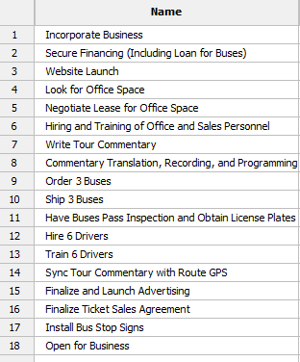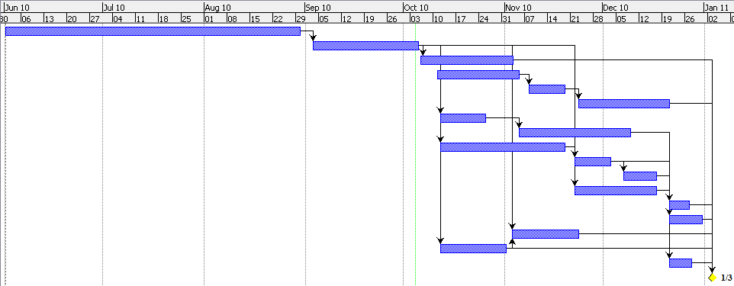

- Overview of First 3 Years of Operation

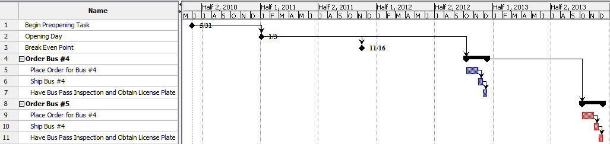

Appendix XIV: Startup Budget

Startup Budget | Cost
Buses | $ 750,000
Drivers | $ 14,400
Bank Payment on Bus Loan | $ 22,830
website | $ 2,000
Brochures | $ 8,500
Decorations | $ 10,000
Bus Shipping & Handling | $ 24,977
Bus Fuel | $ 12,865
Bus Logo | $ 15,000
Bus Stop Signs | $ 27,000
Bus Import Duties | $ 75,000
Credit Card Transactions | $ 859
Insurance | $ 5,500
Office & Parking | $ 5,400
Bus Repair & Maintenance | $ 12,000
Billboards | $ 9,000
Commissions | $ 529
Audio Commentary | $ 22,000
Executive Salaries | $ 39,000
Office Furniture | $ 5,000
Toll Free Number | $ 2,000
Computers, Printers & Servers | $ 10,000
Customer Service Activities | $ 5,000
Tickets | $ 1,500
License Plate & Inspection | $ 150
Uniforms | $ 1,200
Organizing Fee | $ 1,000
Customer Service Personnel | $ 3,600
Customer Service Center | $ 6,000
TOTAL | $ 1,092,310

Appendix XV: 3-Year Income Statement

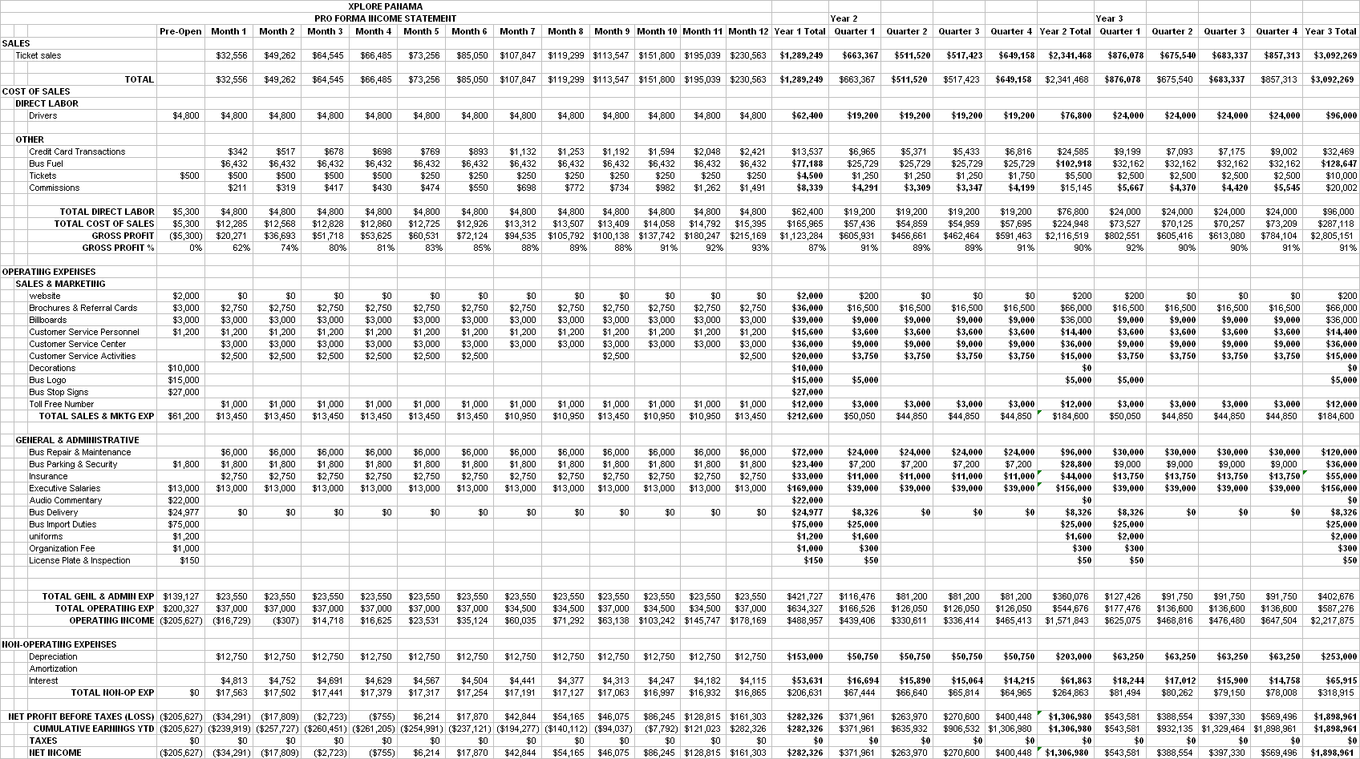

Appendix XVI: 3-Year Statement of Cash Flow

